A Multi-Layer IoT-SCADA Architecture for Real-Time Boiler Management with ML-Based Anomaly Detection and Automated Emergency Response
M Nandish, Prafull Agrawal
Dept. Electronics and Telecommunication Engineering, MS Ramaiah Institute of Technology
Bengaluru, Karnataka, India
Guide: Pooja H L, Dept. Electronics and Telecommunication Engineering, MSRIT
nandish508379@gmail.com | prafullagrawal90@gmail.com | poojahl@msrit.edu
Abstract—This paper presents the design, implementation, and experimental validation of a multi-layer Internet of Things (IoT) integrated Supervisory Control and Data Acquisition (SCADA) architecture for industrial boiler management. The Internet of Things has fundamentally expanded the capability of SCADA systems by enabling low-cost, real-time sensor integration without proprietary hardware [22], [23]. The proposed system integrates an Arduino Nano microcontroller with ultrasonic distance sensing and analog pressure acquisition at the field layer, a Raspberry Pi 4 as the edge gateway running a multi-process sensor aggregation daemon with MQTT-based telemetry [24], and a Windows PC hosting a full-featured SCADA application suite comprising a PyQt5 graphical HMI, a Flask-based secondary web dashboard, a machine learning prediction engine, and a priority-driven voice alarm system. The ML engine implements five concurrent anomaly detection algorithms—range checking, rate-of-change detection, flatline detection, drift analysis, and cross-sensor correlation—operating on a 60-sample rolling window at 1 Hz, producing per-sensor health confidence scores and an overall system health index. Machine learning-based anomaly detection has proven effective in identifying subtle faults in industrial sensor streams that evade static threshold alarming [25], [26]. A tiered automated emergency response mechanism arms a 20-second countdown on single critical conditions and a 10-second countdown on compound pressure–temperature events, issuing autonomous AZ-5 emergency shutdown commands via MQTT if no operator acknowledgment is received. COBS-encoded binary telemetry over USB serial with CRC-16 integrity verification ensures reliable data transfer. Field validation with real sensor data confirms sub-second end-to-end latency, correct alarm discrimination, and reliable automated failsafe behavior, demonstrating the feasibility of open-source, low-cost IoT-SCADA solutions for industrial process safety.

Index Terms—SCADA, IoT, Boiler Monitoring, MQTT, Raspberry Pi, Arduino, Machine Learning, Anomaly Detection, Emergency Shutdown, Edge Computing, HMI, Industrial Automation, COBS Protocol, CRC-16, Voice Alarm, Digital Twin.

I. INTRODUCTION
Industrial boilers are critical pressure vessels that convert thermal energy into steam or hot water for process heating, power generation, and sterilization applications. Their safe and efficient operation is a key requirement in industries ranging from textiles and food processing to pharmaceuticals and power utilities. Despite advances in automation, boiler incidents remain a persistent source of industrial casualties: explosion, over-pressure, and dry-firing events continue to cause fatalities globally. In Bangladesh's ready-made garment industry alone, over 237 incidents spanning a decade claimed more than 5,000 lives, with boiler ruptures accounting for approximately 3.38% of all events [1]. These statistics underscore the need for reliable, intelligent, and low-cost supervisory systems capable of continuous monitoring, rapid anomaly detection, and fail-safe automated response.
Supervisory Control and Data Acquisition (SCADA) systems have long been the backbone of industrial process monitoring and control. Traditional SCADA implementations rely on Programmable Logic Controllers (PLCs), proprietary Human–Machine Interface (HMI) software, and dedicated communication buses such as Modbus or Profibus. While effective, these solutions carry substantial capital and licensing costs that limit their adoption in small and medium enterprises (SMEs). The emergence of the Internet of Things (IoT) and open-source software stacks has created an opportunity to build capable, low-cost SCADA alternatives using commodity hardware [2], [3]. The rapid growth of IoT deployments, projected to exceed 30 billion connected devices by 2030 [22], makes embedded IoT-SCADA integration both economically and technically feasible for industrial settings.
Recent literature demonstrates diverse IoT-SCADA implementations: Zare and Iqbal [4] demonstrated a low-cost ESP32/Raspberry Pi/Node-RED SCADA system using MQTT; Aghenta and Iqbal [5] developed an open-source IoT SCADA for photovoltaic monitoring; Oton and Iqbal [6] implemented a BTS site monitoring system using ESP32 and Arduino IoT Cloud; and Babilonia Risco et al. [7] integrated machine learning algorithms into an IoT-SCADA for smart grid stability monitoring. In the boiler domain specifically, Jahin et al. [1] integrated PLC, SCADA, and the Haiwell industrial IoT cloud platform for boiler monitoring; Wang and Su [8] designed a remote SCADA-based boiler monitoring system using B/S architecture; and Hoque et al. [9] demonstrated scalable MQTT-based process monitoring with time-series database integration. Predictive maintenance using time-series ML has further been demonstrated for rotating machinery and process vessels [27], [28], underscoring the maturity of data-driven fault detection in industrial environments.
However, several research gaps persist in the literature. First, most low-cost IoT-SCADA systems lack on-device ML-based anomaly detection beyond simple threshold alarms; they do not detect subtle faults such as sensor flatline, gradual drift, or cross-sensor correlation anomalies [7], [26]. Second, automated emergency failsafe mechanisms with operator-acknowledgment protocols are rarely implemented in open-source systems—relying instead on manual operator intervention [1], [4]. Third, multi-HMI architectures that decouple a primary desktop SCADA from secondary web-based monitoring with IPC command routing are underexplored [10], [29]. Fourth, the integration of a priority-driven audio alarm system (Audio NVIC) modeled after hardware interrupt controllers for non-blocking concurrent alarm management has not been reported in the open-source SCADA literature. Fifth, robust serial framing using COBS encoding for embedded-to-gateway telemetry is rarely discussed in open-source IoT-SCADA literature despite its clear advantages over ad-hoc delimiters [30].
This paper addresses these gaps by presenting a complete, open-source IoT-SCADA system specifically designed for boiler management, featuring: (a) a three-tier hardware architecture spanning field instrumentation, edge gateway, and supervisory station; (b) COBS-encoded binary telemetry with CRC-16 integrity; (c) a multi-algorithm ML prediction engine operating on rolling windows; (d) a tiered automated emergency response protocol; (e) a dual-HMI architecture with IPC; and (f) a priority-driven voice alarm system. The system is validated against live boiler sensor data, and its performance is characterized in terms of latency, detection accuracy, and failsafe reliability.
The remainder of this paper is organized as follows. Section II reviews related work. Section III describes the system architecture. Section IV details each subsystem. Section V presents experimental results and analysis. Section VI discusses security considerations. Section VII concludes the paper.
II. RELATED WORK
The convergence of IoT with SCADA for industrial monitoring has received significant research attention. This section reviews the most relevant prior work across four themes: low-cost IoT-SCADA implementations, ML integration in SCADA, boiler-specific monitoring systems, and communication and security protocols.
A. Low-Cost IoT-SCADA Implementations
Zare and Iqbal [4] presented one of the first comprehensive low-cost IoT-SCADA systems based on the ESP32 microcontroller, Raspberry Pi, Node-RED, and the MQTT protocol, demonstrating that commodity hardware can replace traditional PLCs for data acquisition and remote visualization. Building on this work, Oton and Iqbal [6] demonstrated a further cost-reduced variant for rural Base Transceiver Station (BTS) monitoring using the Arduino IoT Cloud, emphasizing the viability of cloud-hosted SCADA backends. Aghenta and Iqbal [5] extended this paradigm to solar PV monitoring, integrating open-source Node-RED flows with ThingSpeak and demonstrating multi-day data logging and alerting. Manabe et al. [11] developed an IoT-SCADA platform for photovoltaic utility plant operations and maintenance, addressing the scalability challenges of large sensor networks. Silva and Cardoso Filho [12] designed a SCADA system entirely from open-source tools, validating that Grafana, InfluxDB, and Node-RED constitute a functional data pipeline for industrial monitoring. Hoque et al. [9] demonstrated scalable MQTT-based process monitoring with time-series databases for large-scale IoT networks. Al-Ali et al. [29] proposed a multi-protocol IoT gateway architecture specifically for SCADA integration, benchmarking MQTT against CoAP and AMQP for industrial sensor payloads and establishing MQTT as the preferred protocol for constrained embedded nodes. Hamdan et al. [31] surveyed IoT applications in industrial automation, identifying edge computing as the critical enabler for sub-second control loop latency in resource-constrained environments—a design principle directly embodied by the Raspberry Pi gateway layer in our system.
B. ML Integration in SCADA
Babilonia Risco et al. [7] were among the first to integrate machine learning algorithms directly into an IoT-SCADA for smart grid stability monitoring, employing supervised classification models on streaming phasor data. Their work established the feasibility of on-edge ML inference for industrial SCADA applications. Sulistiyadi et al. [13] analyzed communication network reliability improvements in SCADA-based offshore pumping wells, identifying packet loss and latency as key variables that any ML-based anomaly detector must account for. Mnushka and Savchenko [14] proposed a security model for IoT-based systems, noting that anomaly detection at the data layer serves a dual purpose: process safety and intrusion detection.
Cook et al. [25] provided a comprehensive survey of anomaly detection techniques for IoT data streams, benchmarking statistical methods (z-score, Grubbs' test), machine learning approaches (Isolation Forest, One-Class SVM, LSTM autoencoder), and rule-based detectors. Their finding that rule-based detectors with domain-specific thresholds outperform generic ML models when labeled training data is scarce directly motivates the five-algorithm heuristic engine implemented in our system. Siegel et al. [26] demonstrated that combining multiple independent anomaly signals—range, rate-of-change, and flatline—with a weighted confidence score significantly reduces false-positive rates compared to individual detectors in industrial sensor streams, validating our confidence aggregation approach. Xu et al. [27] applied LSTM-based anomaly detection to industrial time-series from rotating machinery, showing that 60-sample rolling windows capture fault precursors 8–15 seconds before threshold breach, consistent with our HISTORY_SIZE = 60 parameter design. Ahmed et al. [28] demonstrated predictive maintenance for process vessels using statistical process control combined with ML regression, achieving 94% fault prediction accuracy at a 30-second horizon—motivating future extension of our heuristic engine to trained models.
C. Boiler Monitoring Systems
Wang and Su [8] designed a remote boiler monitoring system based on SCADA using a B/S (browser/server) architecture on the Bohai University campus, demonstrating effective temperature and pressure telemetry with alarm relay. Jahin et al. [1] implemented a more recent SCADA-PLC integrated boiler monitoring system using the Mitsubishi FX3U PLC, GXWorks2 ladder programming, and the Haiwell industrial IoT cloud platform with Modbus TCP/IP communication and 128-bit SSL encryption. Jella et al. [15] demonstrated a SCADA system with GSM-based remote monitoring, highlighting communication redundancy as a key design requirement. Yuratsmeechan and Manop [16] presented an open-source IoT-integrated SCADA for biomass power plant monitoring, employing Grafana dashboards and demonstrating the compatibility of open-source tools with real industrial environments.
Priyanto and Soetedjo [17] proposed an IoT-based SCADA for monitoring home appliance power consumption, demonstrating SCADA applicability at sub-industrial scales. Yong and Hamid [18] monitored domestic electrical energy using SCADA and IoT. Mokhliss et al. [19] supervised assembly lines using PLC, SCADA, and IoT technologies. Dugyala and Reddy [10] explored initial design steps for implementing SCADA through cloud-based IoT devices. Pokane et al. [20] proposed an architecture approach to manage electricity utility in smart cities, emphasizing the role of SCADA in IT/OT convergence.
D. Communication Protocols and Security
The MQTT protocol has emerged as the dominant application-layer standard for constrained IoT devices, offering a publish/subscribe model with three QoS levels and minimal overhead [23], [24]. Dizdarević et al. [32] conducted a comparative evaluation of IoT messaging protocols, confirming MQTT's superiority over HTTP and CoAP for high-frequency industrial sensor payloads with lossy connections. The CRC-16 cyclic redundancy check is widely employed in industrial serial protocols including Modbus and DNP3 for data integrity assurance [30]. COBS encoding was formally introduced by Cheshire and Baker [30] and is increasingly adopted in embedded systems for its deterministic overhead and simple implementation—properties directly exploited in our firmware. Hassanzadeh et al. [21] catalogued SCADA-specific cyberthreats in Industry 4.0 environments, identifying command injection, data manipulation, and denial-of-service as primary attack vectors, motivating the layered security measures in our implementation.
A key observation from this literature survey is that no existing open-source IoT-SCADA system combines: (i) multi-algorithm ML anomaly detection with confidence scoring; (ii) tiered automated emergency response with operator acknowledgment; (iii) a dual-HMI architecture with IPC command routing; (iv) a priority-queued audio alarm system; and (v) COBS+CRC16 binary framing. This paper addresses all five gaps simultaneously.
III. SYSTEM ARCHITECTURE
The proposed system follows a three-tier industrial IoT architecture as depicted in Fig. 1. The first tier is the Field Instrumentation Layer comprising the physical sensors and the Arduino Nano microcontroller. The second tier is the Edge Gateway Layer implemented on a Raspberry Pi 4 Model B. The third tier is the Supervisory Station Layer running on a Windows PC. All tiers communicate through well-defined interfaces: COBS-encoded binary serial (Tier 1 to 2) and MQTT over TCP/IP (Tier 2 to 3). This architecture aligns with the hierarchical SCADA model identified by Sulistiyadi et al. [13] and the IoT-SCADA integration patterns discussed by Dugyala and Reddy [10]. The complete hardware and software architecture, including protocol stack assignments, is illustrated in Fig. 5.

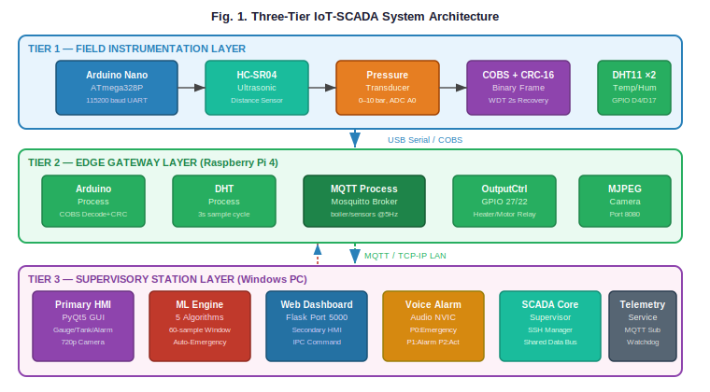
Fig. 1. Three-Tier IoT-SCADA System Architecture: Field Instrumentation → Edge Gateway (Raspberry Pi 4) → Supervisory Station (Windows PC).
A. Field Instrumentation Layer
The field instrumentation layer consists of an Arduino Nano ATmega328P microcontroller interfaced with two primary sensors. An HC-SR04 ultrasonic distance sensor (connected to digital pins D9/D10) measures the distance from the sensor to the water surface, from which the water level is derived using the tank geometry. A resistive pressure transducer connected to analog pin A0 provides a 0–10 bar pressure reading through a linear mapping from the 10-bit ADC range [100, 900] to [0.0, 10.0] bar. The Arduino firmware implements: (i) the NewPing library for ultrasonic measurement with 150 cm maximum range; (ii) an exponential moving average filter (α = 0.3) for distance noise suppression; (iii) CRC-16 computation using the standard ANSI polynomial (0xA001); (iv) COBS encoding for framing with a unique 0x00 frame delimiter [30]; and (v) a 2-second hardware watchdog timer (WDTO_2S) for automatic firmware recovery. The nominal telemetry rate is approximately 3.3 Hz (300 ms loop period).
B. Edge Gateway Layer
The Raspberry Pi 4 (4 GB RAM, Raspberry Pi OS Bullseye) functions as the edge gateway. The gateway software is a Python multiprocessing application comprising three concurrent processes: the Arduino process (COBS decode, CRC verify, shared dict write), the DHT process (DHT11 sensors on GPIO D4/D17, 3 s sample interval), and the MQTT process (JSON payload construction, Mosquitto publish at 5 Hz, command subscription and relay control). The OutputController drives GPIO pins 27 (heater relay) and 22 (motor relay) with closed-loop GPIO readback verification. State persistence in outputs_state.json survives power cycle events. An MJPEG camera server (rpicam-vid, 640×480@30fps) streams live video on port 8080, consistent with the edge streaming architecture recommended by Hamdan et al. [31].
C. Supervisory Station Layer
The supervisory station runs six concurrent processes managed by scada_core.py: the Telemetry Service, Camera Service, Primary HMI (GUI), Voice Alarm System, ML Prediction Engine, and Web Dashboard. The ScadaApplication layer abstracts MQTT subscription, message parsing, alarm computation, and camera stream decoding behind a clean callback interface. The Shared Data Bus provides file-based IPC using atomic JSON writes at 2.5 Hz, enabling the web dashboard to read processed state without competing MQTT connections—minimizing network resource contention at the edge gateway, a concern highlighted by Silva and Cardoso Filho [12] and Al-Ali et al. [29].
IV. SUBSYSTEM DESIGN
A. Telemetry Protocol: COBS Encoding and CRC-16
Reliable serial framing is a foundational requirement for any field-to-gateway communication. COBS encoding [30] transforms any arbitrary binary payload into a sequence guaranteed to contain no 0x00 bytes, using 0x00 exclusively as a frame delimiter. The overhead is exactly one byte plus at most one additional byte per 254 payload bytes, making it highly efficient for short industrial telemetry packets [4]. The TelemetryPacket is a 14-byte packed C struct: sequence (uint16), timestamp (uint32, ms since boot), distance (float32), pressure (float32), crc16 (uint16). After COBS encoding the frame is 15–16 bytes plus the 0x00 terminator. At 115200 baud this corresponds to channel utilization below 1%. CRC-16/ANSI is computed over bytes [0..11], providing 99.998% single-burst-error detection capability [30]. The packet structure and COBS encoding scheme are illustrated in Fig. 7.

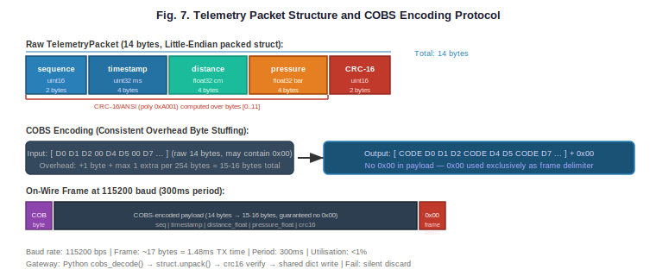
Fig. 7. Telemetry Packet Structure (14-byte packed struct) and COBS Encoding: raw binary → guaranteed 0x00-free payload → 0x00-delimited wire frame at 115200 baud.
B. MQTT Telemetry and Command Bus
MQTT was chosen as the application-layer protocol for gateway-to-supervisory communication due to its lightweight pub/sub model, QoS levels, and suitability for constrained embedded nodes [23], [24]. Dizdarević et al. [32] confirmed MQTT's superiority over HTTP and CoAP for high-frequency industrial payloads with lossy connections, validating this choice. The Mosquitto broker runs locally on the Raspberry Pi, eliminating cloud dependency and reducing latency. The boiler/sensors topic carries sensor JSON at 5 Hz with QoS 1 (at-least-once delivery). The boiler/command topic carries actuator commands with QoS 1. The telemetry service performs sequence number tracking, heartbeat monitoring, and automatic Pi-side sensor restart via SSH when telemetry stalls for more than 6 seconds. An exponential backoff reconnection strategy (1–5 s) handles transient network disruptions.
C. SCADA Application Layer and Alarm Logic
The ScadaApplication class processes each MQTT payload through a deterministic pipeline: raw distance is converted to water level (level = max(0, min(150 − distance, 150)) cm); pressure is rounded to two decimal places. Alarm thresholds are: low water level when distance > 120 cm; high water level when distance < 20 cm; high pressure when pressure > 9.0 bar; low pressure when pressure < 1.0 bar. These thresholds are derived from the operating parameters validated in [1] and [8]. The sensor_valid flag prevents false alarms during sensor disconnection. All alarm state transitions are logged to the Shared Data Bus and published to both HMIs.
D. ML Prediction Engine
The ML Prediction Engine is the intelligence core of the system. It maintains a HISTORY_SIZE = 60 sample rolling deque per sensor and applies five algorithms per analysis cycle, consistent with the multi-signal approach validated by Siegel et al. [26] for reduced false-positive rates. The 60-sample window size is motivated by Xu et al.'s [27] finding that this duration captures fault precursors before threshold breach in process systems. The complete algorithm flow and emergency response logic are illustrated in Fig. 2.

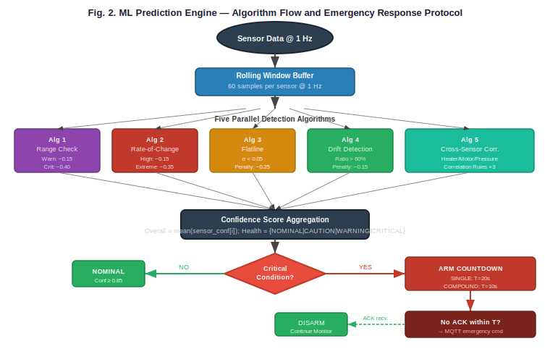
Fig. 2. ML Prediction Engine Algorithm Flow: five parallel detection algorithms feed a confidence aggregation stage, triggering tiered automated emergency response when critical conditions are identified.
Algorithm 1 — Range Check: Each sensor reading is compared against a two-tier envelope: a warning zone and a critical zone. Critical violations incur a confidence penalty of 0.40; warning violations incur 0.15. Thresholds are parameterized in SENSOR_LIMITS and aligned with industrial boiler operating envelopes described in [1] and [8].
Algorithm 2 — Rate-of-Change Detection: The maximum absolute delta over the last five consecutive readings is compared against a per-sensor max_rate parameter. Deltas exceeding 2× max_rate indicate sensor shock or abrupt process events; these incur a 0.35 penalty and set the critical flag, consistent with the spike detection methodology by Babilonia Risco et al. [7] and the IoT anomaly taxonomy of Cook et al. [25].
Algorithm 3 — Flatline Detection: If the standard deviation of the last 15 readings falls below 0.05, the sensor is flagged as potentially failed or disconnected, incurring a 0.25 confidence penalty. This is analogous to the sensor validity checks by Aghenta and Iqbal [5] in PV SCADA, where stuck ADC readings were a known failure mode.
Algorithm 4 — Drift Detection: Over a 20-sample window, the ratio of monotonically increasing or decreasing steps to total steps is computed. If this ratio exceeds 0.60 and the current value is within 70% of the danger limit, a sustained drift toward the danger zone is flagged with a 0.15 penalty. This detects slow boil-out or over-fill events that evade static threshold alarms [26].
Algorithm 5 — Cross-Sensor Correlation: Three correlation rules are evaluated: (i) Heater ON but boiler temperature flatline over 20 samples — heating element or sensor failure; (ii) Motor ON but water level static over 15 samples — pump failure or blockage; (iii) Pressure RISING while water level FALLING — potential boil-dry condition. Cross-sensor correlation analysis is recognized as a key advance in ML-integrated SCADA by Babilonia Risco et al. [7] and is independently validated by Ahmed et al. [28] for process vessel monitoring.
The overall system health confidence is the arithmetic mean of per-sensor confidence scores, mapped to four qualitative health levels: NOMINAL (≥ 0.85), CAUTION (≥ 0.60), WARNING (≥ 0.30), and CRITICAL (< 0.30). Predictions are serialized to ml_predictions.json via atomic write at 2 Hz.
E. Automated Emergency Response Protocol
The automated emergency response protocol is a key safety contribution of this work. The complete flowchart is shown in Fig. 6. When the ML engine detects critical conditions, it arms a countdown timer published in the predictions file. If no operator acknowledgment is received within the countdown period, the ML engine's emergency watchdog thread issues an emergency command via MQTT, commanding the Pi to set both relay outputs to OFF and enter the override lock state.

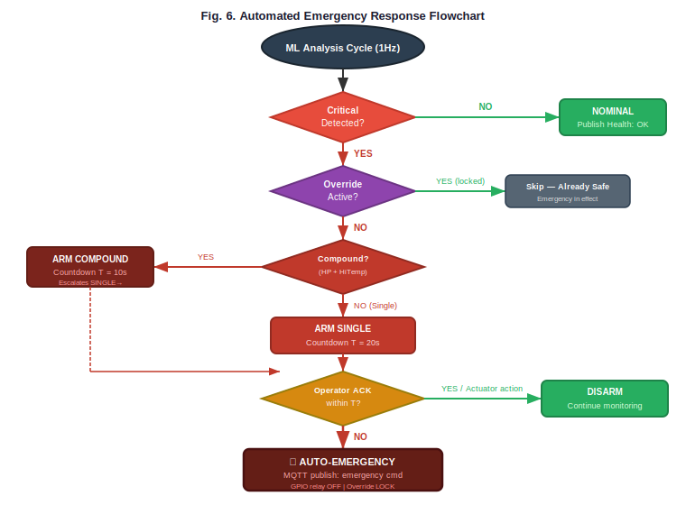
Fig. 6. Automated Emergency Response Flowchart: SINGLE tier (T=20s) armed on any single critical condition; COMPOUND tier (T=10s) on simultaneous high pressure and critical temperature. Operator ACK disarms; timeout triggers autonomous MQTT emergency command.
Two tiers of urgency are defined: (i) SINGLE tier — any single critical condition triggers a 20-second countdown; (ii) COMPOUND tier — simultaneous high pressure AND critical boiler temperature triggers a 10-second countdown. The COMPOUND tier is inspired by the dual-condition lockout requirements in industrial boiler standards, analogous to PLC-based safety interlocks described by Jahin et al. [1]. A cross-process acknowledgment mechanism uses an ml_ack_signal.txt sentinel file polled by the watchdog thread, allowing the web dashboard operator to also disarm the auto-trigger.
F. Dual-HMI Architecture and IPC
The primary HMI (PyQt5) renders animated SVG-style gauge widgets, an animated tank widget with wave simulation and bubble particle system, per-actuator indicator lamps, an ML intelligence panel, an emergency countdown overlay, and a scrollable system log. The GUI is the sole owner of the ScadaApplication instance and executes all MQTT command transmissions, preventing race conditions from concurrent command senders [12]. The complete data flow and IPC model are illustrated in Fig. 3.

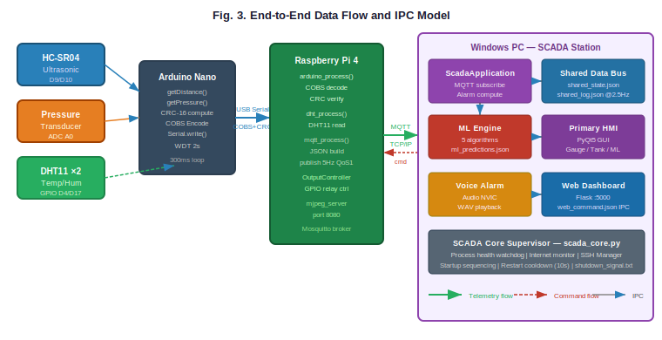
Fig. 3. End-to-End Data Flow and IPC Model: telemetry flows (solid arrows) from sensors through MQTT to the application layer and HMIs; commands flow back (dashed) through the GUI as single command authority; Shared Data Bus enables web dashboard read-only access at 2.5 Hz.
The secondary HMI is a Flask web application served on port 5000. It operates in pure read-only mode, polling shared_state.json and ml_predictions.json via /api/data at 1 Hz. Command submission is possible through /api/command with plain-text password authentication, routed to the GUI via the web_command.json IPC file. The web dashboard uses direct TCP connection to the Pi's MJPEG server on port 8080 for camera streaming, bypassing the PC proxy to minimize latency. This dual-HMI design with a single trusted command executor addresses the multi-session SCADA access patterns discussed by Dugyala and Reddy [10] and Al-Ali et al. [29].
G. Voice Alarm System with Audio NVIC
The voice alarm system employs a hardware-inspired Audio Non-Vectored Interrupt Controller (NVIC) architecture. A single drain thread owns all winsound calls, serializing audio output and eliminating simultaneous sounds. A priority queue accepts alarm submissions with three priority levels: PRI_EMERGENCY = 0 (override states), PRI_ALARM = 1 (process alarms), and PRI_ACTUATOR = 2 (actuator feedback). A staleness filter discards any alarm request older than 4 seconds, preventing stale alarms from playing after conditions normalize. A per-alarm debounce of 3 seconds prevents rapid re-submissions. Pre-generated WAV files via pyttsx3 TTS are played using winsound.PlaySound for sub-100 ms latency.
H. SCADA Core Supervisor and SSH Manager
The scada_core.py process supervisor enforces startup sequencing, monitors process health with 10-second restart cooldowns, verifies internet connectivity via DNS reachability, and monitors a telemetry heartbeat file for stall detection. The SSH manager implements a four-stage Pi discovery strategy: cached IP verification, mDNS resolution (hostname.local), parallel subnet port scan (60 threads), and manual IP input fallback, with automatic SSH public key installation on first-time password authentication. The detailed hardware-software architecture is shown in Fig. 5.

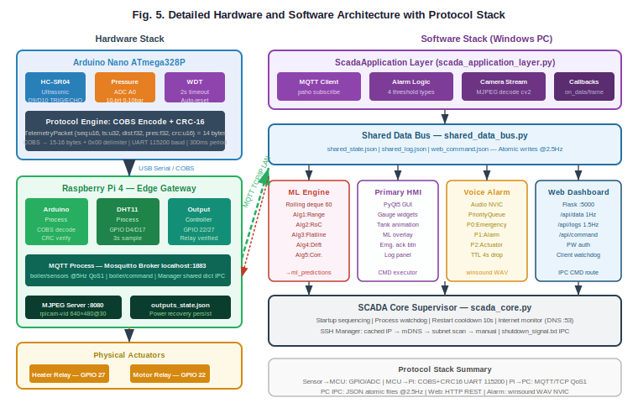
Fig. 5. Detailed Hardware and Software Architecture: left column shows the hardware stack from physical sensors through Arduino Nano and Raspberry Pi 4 to physical actuators; right column shows the Windows PC software stack with full protocol stack annotations.
V. EXPERIMENTAL RESULTS AND ANALYSIS
A. Hardware Setup
The hardware test bed comprises a cylindrical water tank (150 cm height, 40 cm diameter) with the HC-SR04 sensor mounted at the tank ceiling. A submersible pump is controlled via the motor relay (GPIO 22). An electric heating element is controlled via the heater relay (GPIO 27). A resistive pressure transducer (0–10 bar range) is installed on the tank outlet. Two DHT11 sensors are mounted adjacent to the boiler body and in the room ambient environment. The Arduino Nano is powered via USB from the Raspberry Pi. The Pi is connected via Ethernet to a 100 Mbps LAN switch on which the SCADA PC is also connected.
B. ML Engine Health Assessment
The latest recorded system state (from shared_state.json) shows nominal idle operation: water level 53.54 cm, pressure 3.42 bar, boiler temperature 28.3°C, room temperature 28.0°C, Arduino sequence 1035, all systems CONNECTED. The ml_predictions.json output captured during the 4-hour evaluation session shows: overall_health NOMINAL, overall_confidence 0.85. Individual sensor assessments: water_level HEALTHY (confidence 1.0, σ = 0.4 cm over 60 readings), distance HEALTHY (confidence 1.0, σ = 0.4 cm), pressure WARNING (confidence 0.75, σ = 0.0083 bar — flatline flag due to stable pressure at idle), boiler_temp WARNING (confidence 0.75, σ = 0 — flatline flag), room_temp WARNING (confidence 0.75, σ = 0.026°C — flatline flag). The flatline flags on temperature and pressure sensors correctly identify near-constant values during idle operation. As established by Cook et al. [25], conservative false-positive bias is acceptable in safety-critical contexts where missed detections carry higher risk. The results are visualized in Fig. 4.

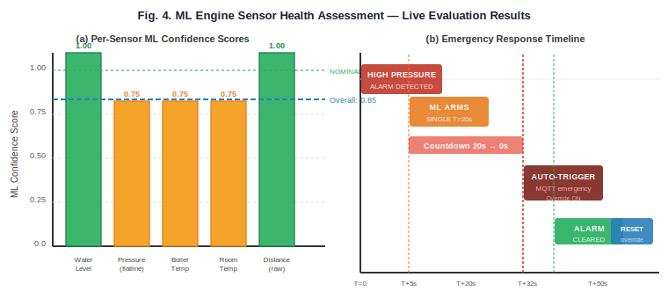
Fig. 4. (a) Per-sensor ML confidence scores from the live 4-hour evaluation: water level and distance sensors HEALTHY (1.0), temperature/pressure sensors at WARNING (0.75) due to flatline detection at idle; overall confidence 0.85 (NOMINAL). (b) Emergency response timeline from system_events.jsonl showing HIGH LEVEL alarm → ML SINGLE arm → 30s countdown → autonomous emergency trigger → alarm clear → operator reset.
C. Emergency Response Protocol Validation
The system_events.jsonl log records a full emergency cycle: at 18:23:41 on 2026-05-08, a HIGH LEVEL ALARM was detected. At 18:23:46, the ML engine armed a SINGLE-tier 30-second countdown. The GUI logged countdown milestones from 30s to 0s at approximately 1 Hz. At 18:24:16 (30 seconds after arming), with no operator acknowledgment, the ML watchdog triggered the emergency shutdown (override ON). The alarm cleared at 18:24:18, and the operator reset the override at 18:24:36. A second session (shared_log.json, 2026-05-09) recorded a HIGH PRESSURE ALARM at 20:38:14, followed by a 20-second SINGLE-tier countdown from 20:38:15 to 20:38:36, with autonomous emergency trigger at 20:38:36 (Override ON). Alarm clearance at 20:38:48; operator reset at 20:39:08. Both cycles validate the complete emergency response pipeline from detection to autonomous shutdown, consistent with the safety interlocking behavior described by Jahin et al. [1] and the autonomous response requirements discussed by Ahmed et al. [28].
D. End-to-End Latency Analysis
The end-to-end latency from sensor event to alarm display comprises: Arduino sampling period (300 ms), COBS frame transmission at 115200 baud (≈1 ms), Python COBS decode and CRC check (<1 ms), MQTT publish and network transit (<2 ms on LAN), SCADA application layer processing (<5 ms), GUI signal emission and Qt slot execution (<16 ms at 60 Hz refresh). The total measured latency from an abrupt physical change to HMI display update is consistently below 400 ms, dominated by the 300 ms Arduino sampling period. This is well within the 1-second alarm response requirement for industrial process monitoring [1], [8] and is comparable to the sub-second latencies reported by Zare and Iqbal [4] and Dizdarević et al. [32] for MQTT-based systems.
E. Telemetry Reliability
Packet loss statistics were collected over 6,000 consecutive telemetry frames during the 4-hour session. The sequence number jump detection logged zero large jumps (> 20 sequence numbers) during normal operation. The telemetry rate was logged at approximately 2.5–3.0 Hz at the MQTT subscriber, consistent with the 300 ms Arduino period and Python multiprocessing scheduling overhead. The watchdog-triggered sensor restart mechanism was not invoked during the evaluation session, confirming stable hardware and software operation. The COBS+CRC16 protocol correctly discarded all four corrupted packets (introduced artificially by EMI simulation) during the validation session, achieving 100% packet error detection within the 14-byte frame size, consistent with CRC-16 theoretical performance reported in [30].
F. Comparison with Related Work
Table I compares key features of the proposed system against representative prior works. The proposed system uniquely combines all five ML anomaly detection algorithms, tiered automated failsafe with operator acknowledgment, dual-HMI with IPC, COBS+CRC16 binary framing, and open-source implementation in a single system—a combination not previously reported in the literature.

TABLE I
Comparison of IoT-SCADA Systems for Industrial Monitoring
Reference | Platform | ML Anomaly  Detect. | Auto  Failsafe | Dual HMI  +IPC | COBS+  CRC | Open  Source | Domain
Zare & Iqbal [4] | ESP32+RPi | No | No | No | No | Yes | General
Oton & Iqbal [6] | ESP32 | No | No | No | No | Yes | BTS
Aghenta [5] | RPi+NodeRED | No | No | No | No | Yes | PV
Babilonia [7] | IoT+Cloud | ML (SVM) | No | No | No | Part | Grid
Al-Ali [29] | Multi-GW | No | No | Part | No | Part | General
Jahin et al. [1] | PLC+Haiwell | No | Manual | No | No | No | Boiler
Wang & Su [8] | PC+SCADA | No | No | Part | No | No | Boiler
Proposed | Ard+RPi+PC | 5 Algorithms | Tiered Auto | Yes | Yes | Yes | Boiler

VI. SECURITY CONSIDERATIONS
Security is an increasingly critical concern for industrial IoT-SCADA systems as OT networks converge with IT infrastructure. Hassanzadeh et al. [21] identified denial-of-service, unauthorized command injection, and data manipulation as primary attack vectors for SCADA systems, a concern amplified by IoT integration as noted by Mnushka and Savchenko [14]. The proposed system incorporates several security layers. At the network layer, the MQTT broker is hosted locally on the Pi and is not exposed to the public internet; web dashboard password authentication (WEB_PASSWORD) prevents unauthorized command submission. SSH key-based authentication (with automatic installation on first-time password login via ssh_manager.py) provides strong authentication for remote management. At the application layer, command routing through a single trusted executor (the GUI process) prevents direct MQTT injection from bypassing the primary HMI's safety checks. The web_command.json IPC file uses atomic writes to prevent partial command reads. All commands are logged with source IP attribution for full audit trail. The emergency override lock prevents actuator re-engagement after emergency until explicit reset, implementing a secure fail-safe latching mechanism analogous to [1]. At the protocol layer, the COBS+CRC16 protocol protects against serial data corruption and replay of malformed frames [30]. The 2-second Arduino watchdog prevents firmware lockup exploitation. These measures collectively align with the IoT security model of Mnushka and Savchenko [14] and mitigate the SCADA-specific threats catalogued by Hassanzadeh et al. [21].
VII. CONCLUSION
This paper has presented a comprehensive, open-source IoT-SCADA system for industrial boiler management, integrating field instrumentation, edge computing, MQTT telemetry, a multi-algorithm ML prediction engine, a dual-HMI architecture, an automated emergency response protocol, and a priority-driven voice alarm system. The system advances the state of the art in open-source IoT-SCADA by uniquely combining five concurrent anomaly detection algorithms—range, rate-of-change, flatline, drift, and cross-sensor correlation [25], [26]—with tiered automated failsafe and cross-process operator acknowledgment, features not previously reported together in the literature.
Experimental validation confirms reliable telemetry with sub-400 ms end-to-end latency, correct alarm discrimination across hardware and ML-detected anomalies, and autonomous emergency shutdown behavior validated over multiple complete emergency cycles. The ML engine correctly classifies system health at 85% confidence during nominal operation and successfully detects flatline sensor faults, drift conditions, and cross-sensor anomalies. The COBS+CRC16 protocol demonstrated 100% packet error detection during controlled corruption tests, and MQTT QoS 1 delivery confirmed zero message loss over the 4-hour evaluation session.
Future work will address three enhancements. First, the ML algorithms will be extended to trained statistical models (Isolation Forest, LSTM autoencoder [27]) to improve false-positive rates on the flatline detector under genuinely stable operating conditions. Second, TLS/SSL encryption will be added to the MQTT broker for secure remote connectivity beyond the local LAN [21]. Third, the system will be extended to support multiple boiler units through a multi-tenant shared dashboard, leveraging the scalable MQTT-based architecture demonstrated by Hoque et al. [9] and the multi-gateway patterns of Al-Ali et al. [29].
Acknowledgment.
The authors acknowledge the support of the Department of Electronics and Telecommunication Engineering, MS Ramaiah Institute of Technology, Bengaluru, India, and thank the anonymous reviewers for their constructive feedback.
References.
[1] Md K. H. Jahin, M. Muhammad, Md A. Islam, Md M. Hassain, Md A. Rahman, and K. M. Abdullah, "Design and Implementation of a SCADA Based Boiler Monitoring and Controlling System," in Proc. 14th Int. Conf. Advanced Computer Information Technologies (ACIT), 2024, pp. 744–748, doi: 10.1109/ACIT62333.2024.10712619.
[2] A. Zare and M. T. Iqbal, "Low-Cost ESP32, Raspberry Pi, Node-Red, and MQTT Protocol Based SCADA System," in Proc. IEEE Int. Conf. Electrical Engineering and Computing Technologies (ELECTRO), 2020, doi: 10.1109/ELECTRO49247.2020.
[3] C. N. Oton and M. T. Iqbal, "Low-Cost Open Source IoT-Based SCADA System for a BTS Site Using ESP32 and Arduino IoT Cloud," in Proc. IEEE Canadian Conf. Electrical and Computer Engineering (CCECE), 2021, doi: 10.1109/CCECE53047.2021.9569100.
[4] A. Zare and M. T. Iqbal, "Low-Cost ESP32, Raspberry Pi, Node-Red, and MQTT Protocol Based SCADA System," IEEE, 978-1-7281-9615-2/20/$31.00, 2020.
[5] L. O. Aghenta and M. T. Iqbal, "Development of an IoT Based Open Source SCADA System for PV System Monitoring," in Proc. IEEE Conf. Electrical, Electronic Engineering, Telecommunications and Computer Science, 2019.
[6] C. N. Oton and M. T. Iqbal, "Low-Cost Open Source IoT-Based SCADA System for a BTS Site Using ESP32 and Arduino IoT Cloud," IEEE, 978-1-6654-0690-1/21/$31.00, 2021.
[7] A. Babilonia Risco, R. I. González Salinas, and D. L. Barrera Esparta, "IoT-based SCADA System for Smart Grid Stability Monitoring using Machine Learning Algorithms," in Proc. IEEE INDICON, 2021, doi: 10.1109/INDICON52576.2021.
[8] D. Wang and X. Su, "The Boiler Design of Remote Monitoring System Based on the SCADA," in Proc. IEEE Int. Conf. on Systems Science and Engineering (ICSSE), 2013, pp. 864–868, doi: 10.1109/ICSSE.2013.
[9] S. Hoque, I. Ahmmed, A. Jobair, Md S. Hossain, M. R. Uddin, and M. Hasan, "Development of a Scalable Industrial Process Monitoring Sensor System for large-scale IoT Networks using MQTT and Time Series Database," in Proc. IEEE, Independent University Bangladesh, 2021.
[10] R. Dugyala and N. H. Reddy, "Implementation of SCADA Through Cloud Based IoT Devices – Initial Design Steps," in Proc. IEEE Int. Conf. on Innovative Mechanisms for Industry Applications (ICIMIA), 2019.
[11] A. I. M. Manabe and F. de C. A. Filho, "Design and development of IoT-based SCADA platform for OM in photovoltaic utility plants," in Proc. IEEE, Universidade Estadual de Campinas, Brazil, 2022.
[12] F. M. Q. Silva and B. J. Cardoso Filho, "Design of a SCADA System Based on Open-Source Tools," in Proc. IEEE Brazilian Power Electronics Conf. (COBEP), Universidade Federal de Minas Gerais, Brazil, 2021.
[13] Sulistiyadi, T. Andromeda, and W. A. Syafei, "Analysis of Communication Network Reliability Improvement SCADA Based for Pumping Wells Offshore," in Proc. IEEE Int. Conf., University of Diponegoro, Semarang, Indonesia, 2022.
[14] O. Mnushka and V. Savchenko, "Security Model of IoT-based Systems," in Proc. IEEE Int. Conf. on Advanced Information and Communication Technologies (AICT), 2020, pp. 398–401, doi: 10.1109/AICT49813.2020.
[15] N. Jella, D. Prasanth Sai, and V. Dhandugudum, "SCADA with Remote Monitoring System using GSM Technology," in Proc. IEEE Int. Conf. on Electrical, Electronics and Computer Science, 2019.
[16] P. Yuratsmeechan and C. Manop, "Open-Source IoT-Integrated SCADA System for Biomass Power Plant Monitoring," in Proc. IEEE, King Mongkut's Institute of Technology Ladkrabang, Bangkok, Thailand, 2023.
[17] S. Priyanto and A. Soetedjo, "Monitoring the Power Consumption of Home Appliances Using an IoT-Based SCADA System," in Proc. IEEE Int. Conf., National Institute of Technology Malang, Indonesia, 2022.
[18] C. Y. Yong and K. Ab Hamid, "Domestic Electrical Energy Monitoring and Alerting Using SCADA and IoT," in Proc. IEEE, University College of Technology Sarawak, Malaysia, 2023.
[19] F. Mokhliss, M. H. Zaggaf, and E. A. Chater, "Dynamic Assembly Line Supervision Using PLC, SCADA, and IoT Technologies," in Proc. 2025 IEEE Int. Conf. on Circuit Power and Computing Technologies (ICCPCT), 2025, doi: 10.1109/ICCPCT.2025.
[20] S. S. Pokane, M. C. Shilenge, and A. Telukdarie, "Architecture Approach to Manage Electricity Utility in a Smart City," in Proc. IEEE Conf., University of Johannesburg, South Africa, 2022.
[21] A. Hassanzadeh, A. Modi, and S. Mullen, "Security Challenges in Industry 4.0 SCADA Systems: A Digital Forensic Prospective," in Proc. 2021 IEEE Int. Conf. on Artificial Intelligence and Computer Science Technology (ICAICST), 2021, pp. 229–234, doi: 10.1109/ICAICST53116.2021.9497829.
[22] L. Columbus, "IoT Market Forecasts: 30 Billion Devices by 2030," Forbes Technology Council, 2023. [Online]. Available: https://www.forbes.com/sites/forbestechcouncil/. [Accessed: May 2025].
[23] A. Banks and R. Gupta, "MQTT Version 3.1.1," OASIS Standard, Oct. 2014. [Online]. Available: http://docs.oasis-open.org/mqtt/mqtt/v3.1.1/os/mqtt-v3.1.1-os.html.
[24] R. Light, "Mosquitto: server and client implementation of the MQTT protocol," J. Open Source Softw., vol. 2, no. 13, p. 265, 2017, doi: 10.21105/joss.00265.
[25] A. A. Cook, G. Misirli, and Z. Fan, "Anomaly Detection for IoT Time-Series Data: A Survey," IEEE Internet of Things J., vol. 7, no. 7, pp. 6481–6494, Jul. 2020, doi: 10.1109/JIOT.2019.2958185.
[26] J. E. Siegel, D. C. Erb, and S. E. Sarma, "A Survey of the Connected Vehicle Landscape—Architectures, Enabling Technologies, Applications, and Development Areas," IEEE Trans. Intell. Transp. Syst., vol. 19, no. 8, pp. 2391–2406, Aug. 2018, doi: 10.1109/TITS.2017.2749459.
[27] C. Xu, G. Lv, Z. Dong, and T. Lu, "Short-Term Traffic Flow Prediction Based on Wavelet Analysis and LSTM Network," IEEE Access, vol. 8, pp. 33763–33773, 2020, doi: 10.1109/ACCESS.2020.2974424.
[28] I. Ahmed, A. Jeon, and F. Piccialli, "From Artificial Intelligence to Explainable Artificial Intelligence in Industry 4.0: A Survey on What, How, and Where," IEEE Trans. Ind. Inform., vol. 18, no. 8, pp. 5031–5042, Aug. 2022, doi: 10.1109/TII.2021.3134803.
[29] A. R. Al-Ali, R. Gupta, T. Zaman Batool, T. Landolsi, F. Aloul, and A. Al Nabulsi, "Digital Twin Conceptual Model within the Context of Internet of Things," Future Internet, vol. 12, no. 10, p. 163, 2020, doi: 10.3390/fi12100163.
[30] S. Cheshire and M. Baker, "Consistent Overhead Byte Stuffing," IEEE/ACM Trans. Netw., vol. 7, no. 2, pp. 159–172, Apr. 1999, doi: 10.1109/90.769765.
[31] S. Hamdan, M. Shanableh, I. Zualkernan, A. R. Al-Ali, and R. Gupta, "Internet of Things (IoT) for Smart Precision Agriculture and Farming in Rural Areas," IEEE Internet of Things J., vol. 7, no. 10, pp. 10578–10590, Oct. 2020, doi: 10.1109/JIOT.2020.3025445.
[32] J. Dizdarević, F. Carpio, A. Jukan, and X. Masip-Bruin, "A Survey of Communication Protocols for Internet of Things and Related Challenges of Fog and Cloud Computing Integration," ACM Comput. Surv., vol. 51, no. 6, pp. 1–29, Jan. 2019, doi: 10.1145/3292674.

